Task 2.1 Migrating Database

When starting up your python server, you should be met by a message similar to this:



This means that we will have to migrate our database in order for the changes to take effect on the website.

The first thing to do will be to install the SQLite extension for VSCode

(I recommend installing SQLite and SQLite view for now)

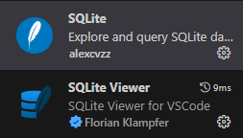

After you have downloaded these extensions, open a new CMD window and navigate to your portfolio directory

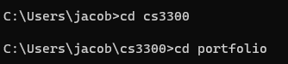

Once you have made it here, type the command “python manage.py migrate”

This will apply all currently available migrations.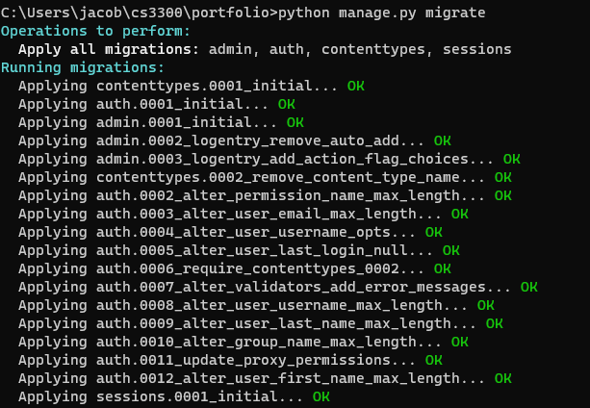

For the next part we will need to have created a SuperUser, as there should be other documentation on this, I will just give the brief command to create the superuser:

“Python manage.py createsuperuser”

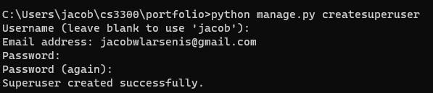

After the super user is created, we can view all of our databases in the website, from now on, whenever a new migration needs to be made (whenever a new model or update to model is made), you will need to type the following commands in order:

“Python manage.py makemigrations”

“Python manage.py migrate”

